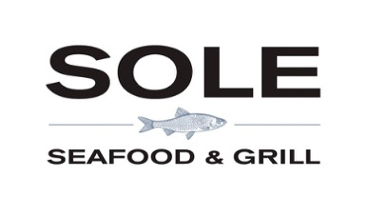

Appetisers

**Curried Parsnip & Apple Soup V**

Crisp fried parsnip ribbons

**Seafood Chowder**

Irish fish and shellfish, creamed broth

**Caesar Salad**

Cos, parmesan, crisp bacon, Cajun chicken

**Scallops (€3 Supp)**

Jerusalem artichoke puree, pea & pancetta mash

Artichoke crisps

**Prawn Cocktail**

Poached prawns, Marie Rose sauce, watercress,  
cos, brown soda bread

**Howth Smoked Irish Organic Salmon**

Red onion, crisp capers, chive crème fraiche, brown soda bread



Entrées

**Halibut**

Red onion, caper & herb fried potatoes

Black olive tapenade, asparagus, seashore leaves

**9oz Sirloin Steak (€5 Supp)**

Hannan’s salt aged Irish Beef, shallot mash & baby veg

**Monkfish**

Smoked bacon & lentil stew, sprout fricassee, parsnip puree

**Duck Breast**

Pan roast, braised red cabbage, swede & potato gratin,

Caramelised fig, Madeira jus

**Moules Frites**

West Cork mussels, white wine cream, home cut chips

**Fish Pie**

Irish fish and shellfish, creamed vegetable broth, cheddar mash

**Chestnut Gnocchi V**

Sprout & sage fricassee, braised Paris Brown mushrooms

Beetroot gel



Desserts

**Christmas Pudding**

Gingerbread ice cream & DWD whiskey crème anglaise

**Chocolate Bar**

Dark & milk chocolate mousse, Genoise sponge, candied orange, Jaffa Cake ice cream

**Selection of Wexford Ice Cream**

Vanilla and Chocolate tuile

**Eggnog Panna Cotta**

Mulled berry compote

**Tea & Coffee**

**Petite Fours**

*Discretionary 12.5% service charge on parties of 6 or more*

*T: +353 (0) 1 5442300 E:* [*Reservations@Sole.ie*](mailto:Reservations@Sole.ie) *W:* [*www.SOLE.IE*](http://www.SOLE.IE)

Christmas Lunch

*Three Courses €52pp*